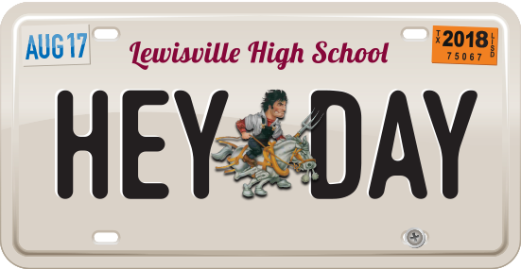

**HEY! DAY SCHOOL AND BOOSTER CLUB FORM**

Friday, August 16, 2019

**Lewisville High School (Football Stadium) Contact: Kim Teamer**

**Event set up: 5:00-6:00 p.m. Phone: 972.998.9798**

**Event: 7-9 p.m. Email**[**: heyday@lisd.net**](mailto:heyday@lisd.net) **www**[**.lisd.net**](mailto:Heyday@lisd.net)**/heyday**

**School/Booster Club Name**

**Contact Person**

**Address:**

**City/State/Zip:**

**Cell Email**

**Website**

**About Hey! Day**

*#HeyDay19 is a family-friendly, informative and fun event designed to unite the community, celebrate the new school year* *and rally support for Lewisville High School and its feeder schools. Profits are used to offset event costs and benefit education for students attending all participating campuses, including elementary schools, middle schools, LHS Harmon, LHS Killough and LHS! Your contribution is greatly appreciated. Thousands have attended Hey! Day over the past seven years.*

**Participation at Hey! Day**

**(PLEASE CHECK ALL THAT APPLY)**

**DEADLINE: FRIDAY, AUGUST 9**

**Email form to** [**heyday@lisd.net**](mailto:HeyDay@lisd.net) **or mail to:**

**Hey! Day Event, c/o Allison Stamey, 1098 W. Main Street, Lewisville TX, 75067**

**SCHOOL, BOOSTER CLUB BOOTH**

**Booth Description**

**Booth Activities**

▪  Booth space is 10x10 (can request additional space if necessary). Booth approval is required.

▪  **You will be supplied with a tables and chairs.** Signage is welcomed, tents are prohibited.

▪  Child-friendly games and activities centered around your sport or club is encouraged.

▪  See separate form for details on rules and regulations.